The EFAST Exam

The FAST ultrasound exam is utilized by emergency physicians and trauma surgeons for the evaluation and diagnosis of thoracic, cardiac, and abdominal injuries. FAST stands for Focused Assessment with Sonography for Trauma. The E-FAST, or extended FAST exam, has added the evaluation of thoracic structures for hemothorax and pneumothorax. This is a rapid, portable, and non-invasive way to detect hemoperitoneum, hemothoraces, pneumothroraces, and pericardial effusions in trauma patients.

An E-FAST ultrasound is indicated in all trauma patients with blunt or penetrating trauma to the chest or abdomen. It should be performed immediately after the primary survey of the Advanced Trauma Life Support (ATLS) protocol. It can be performed simultaneously with resuscitation, or as part of the secondary survey¹.

The exam may be performed with multiple probes. A curvilinear array transducer (Figure 1) or a phased array transducer (Figure 2) can be used to obtain all views in the E-FAST exam .

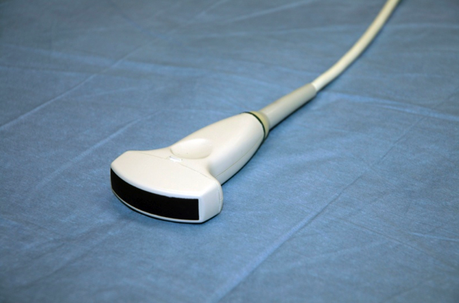
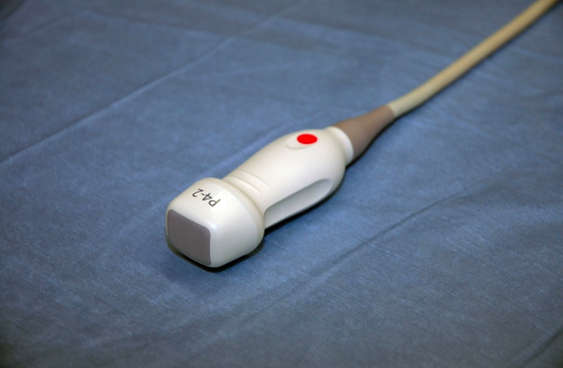
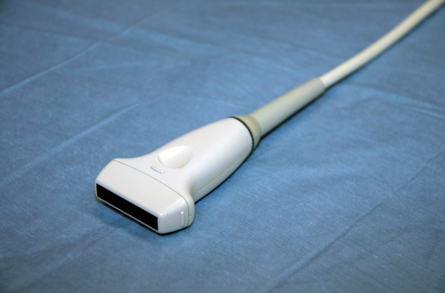
Figure 1: Curvilinear array transducer; Large curved footprint
Figure 2: Phased array transducer; Small flat footprint
Figure 3: Linear array transducer; Flat footprint, high frequency

Advantages to the phased array transducer includes a smaller footprint, which facilitates imaging between rib spaces. If timing permits, a high frequency linear probe (Figure 3) may be used for evaluation of the chest wall for pneumothorax. However, the phased array transducer and the curvilinear abdominal transducer will work well for this evaluation by adjusting the depth of the field if you do not have a high frequency probe or do not have time to change probes during the scan.

The standard FAST exam currently involves four views. The extended-FAST exam contains two additional views of the right and left chest wall. The first view is the right upper quadrant view. This is often called Morison's view. The position of the ultrasound probe is longitudinal in the midaxillary line around the 8th to 11th intercostal spaces, with the marker dot of the probe directed toward the patient’s head (Figure 4). Rotating the probe counterclockwise will help minimize rib shadowing. This view will demonstrate the right pleural space, right diaphragm, liver, and kidney (Figure 5). It allows for the evaluation of the potential space between the liver and kidney, called Morison's pouch.

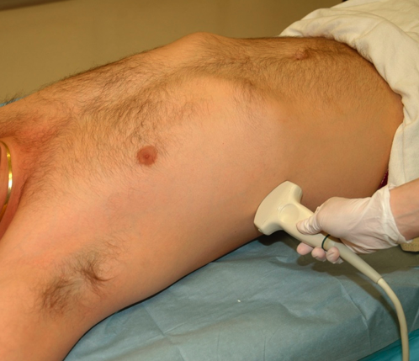
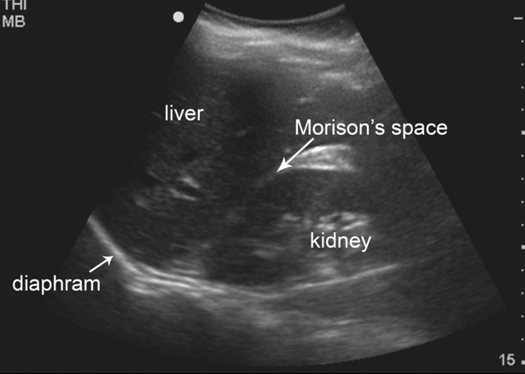
Figure 4: Right upper quadrant probe position

Figure 5: Right upper quadrant view, or Morison’s view

Morison’s pouch is the most dependent area of the peritoneal cavity in the RUQ and is where free fluid is most likely to be identified. A hemoperitoneum will appear as an anechoic (black area) between the liver and kidney (Figure 6). It is also important to visualize caudally around the lower live edge. It is in this view that the right pleural space can be visualized for the evaluation of hemothrorax or pleural fluid. A normal view of the pleural space will have the same echogenicity above the diaphragm as the liver below the diaphragm. An anechoic area above the diaphragm represents a hemothorax (Figure 7).

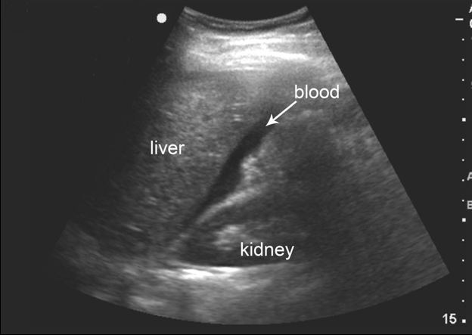
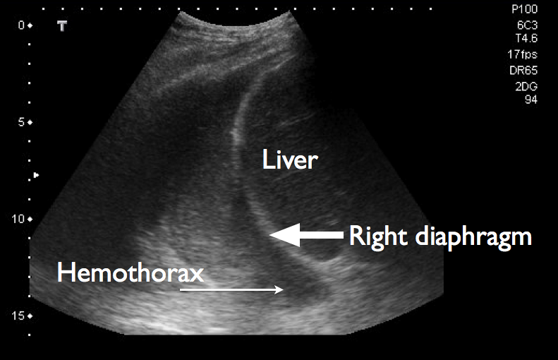
Figure 6: Positive Morison’s view
Figure 7: Right hemothorax

The second view is the left upper quadrant view, or perisplenic view. The position of the ultrasound probe in the LUQ is also longitudinal in the posterior axillary line around the 6th-9th intercostals spaces with the marker dot toward the patient’s head (Figure 8). This view is more difficult to obtain. The probe is usually more posterior and cephalid in comparison to probe placement on the right upper quadrant. A normal perisplenic view will visualize the left pleural space, left diaphragm, spleen and kidney (Figure 9). Free fluid in the LUQ will collect differently due to the phrenicocolic ligament that prevents fluid from filling the splenorenal space¹. Free fluid in the LUQ will more likely be found in the subphrenic region under the left diaphragm or the inferior tip of the spleen (Figure 10). It is rare to find free fluid between the spleen and the kidney. Again to evaluation the left pleural space, the probe is simply angled or moved superiorly. A hemothorax will appear as an anechoic area above the diaphragm.

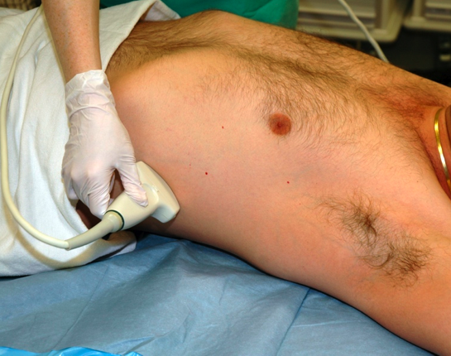
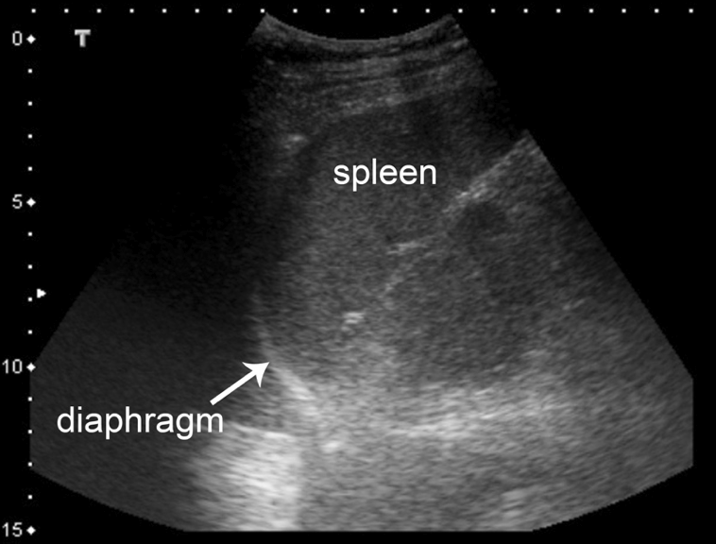
Figure 8: Left upper quadrant probe position
Figure 9: Left upper quadrant view, or perisplenic view

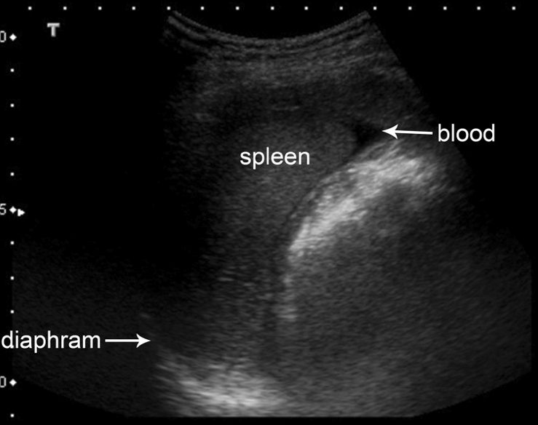
Figure 10: Positive perisplenic view, blood will accumulate around the tip of the spleen

The third view is the pelvic view. The ultrasound should be placed directly superior to the pubic symphysis with the maker dot pointed toward the patient’s head (Figure 11). In females, a normal view will visualize the bladder, uterus, and the posterior cul-de-sac (pouch of Douglas) (Figure 12a) . In males, the bladder and retrovesicular space are visualized (Figure 13). Intraperitoneal fluid will collect in the posterior cul-de-sac (or pouch of Douglas) in females (Figure 12b) and in the retrovesicular pouch in males (Figure 13b). This view is suboptimal if the bladder is empty and should be performed before foley catheter placement.
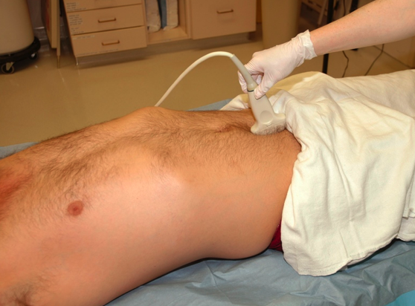
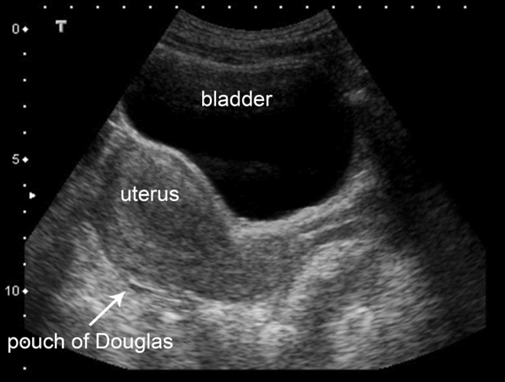
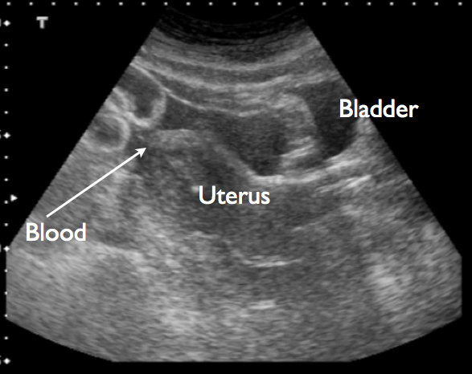
Figure 11: Pelvic view probe positioning
Figure 12a: Normal female pelvic view
Figure 12b: Positive pelvic view in a female, blood will accumulate behind the uterus

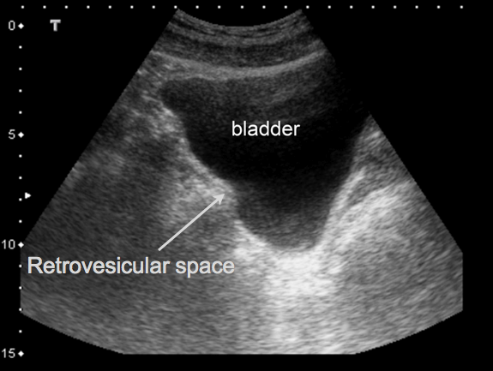
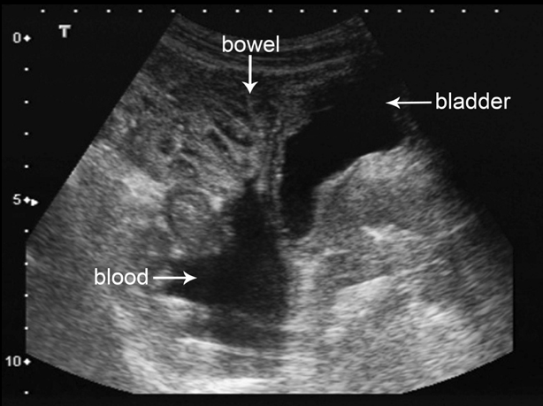
Figure 13: Normal pelvic view in a male
Figure 13b: Positive pelvic view in a male, blood will accumulate behind the bladder

The fourth view is the cardiac view. The ultrasound probe is place in the subxiphoid position transversely to evaluate the heart for a pericardial effusion (Figure 14). A normal view will visualize the liver, pericardial space, and right ventricle (Figure 15). If you are unable to visualize the pericardium in the subxiphoid view, the probe should be moved to the parasternal position. In this position, the probe is placed in the left parasternal position between the second and fourth intercostals spaces (Figure 16). The normal images in this view should be of the right ventricle, left atrium, left ventricle, mitral valve, aortic valve and ascending aorta (Figure 17). There is typically confusion about the orientation of the marker dot on the probe while performing the cardiac portion of the E-FAST exam. This is because in abdominal ultrasounds, the marker dot on the probe correlates to the left side of the screen. This is reversed in standard cardiac ultrasounds, the marker dot on the probe correlates to the right side of the screen. By learning the standard images on the E-FAST exam and practicing their reproduction, the marker dot on the probe becomes irrelevant. If the image appears reversed in comparison to standard images, simply flip the probe 180 degrees to obtain images in the correct orientation. In the subxiphoid view, a pericardial effusion will be seen between the liver and the right ventricle (Figure 18). In the parasternal view, an effusion can be seen superior to the right ventricle or around the left atrium and left ventricle.
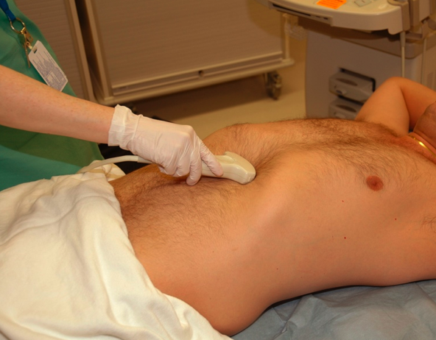
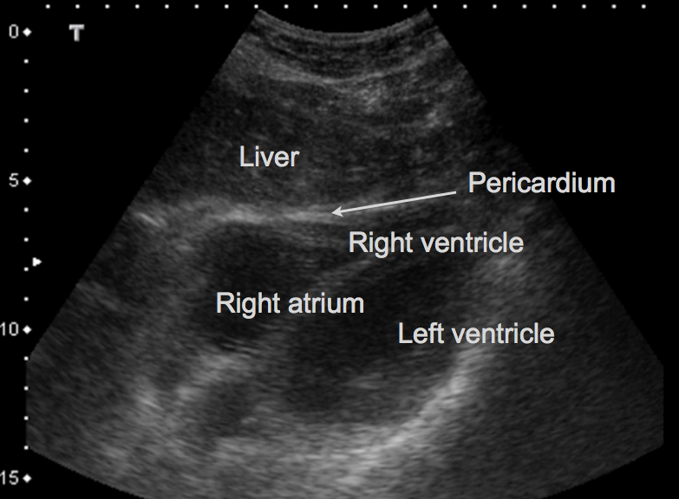
Figure 14: Subxiphoid probe positioning, cardiac view
Figure 15: Normal subxiphoid cardiac view

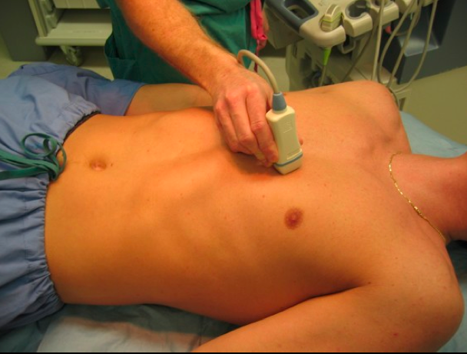
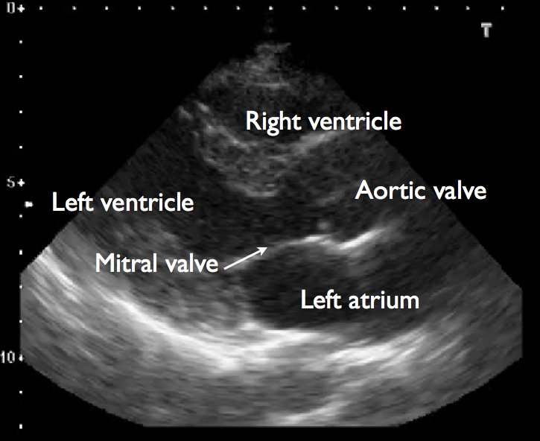
Figure 16: Parasternal long axis probe positioning, cardiac view
Figure 17: Normal parasternal long axis view

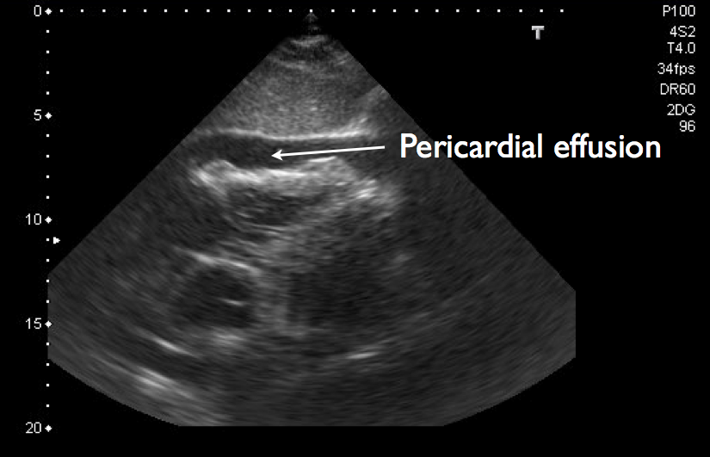
Figure 18: Pericardial effusion, subxiphoid view

Evaluation of the upper right and left pleural spaces for pneumothraces begins at the 3/4th intercostals spaces in the midclavicular line, with the marker dot pointed toward the patient’s head (Figure 19). In the supine position, this will be the most likely area to identify a pneumothorax. The probe should be placed longitudinally to include two adjacent ribs. A normal pleural space will show the hyperechoic layers of the pleural sliding underneath the ribs, a “shimmering” line that will move back and forth (Figure 20). A normal artifact called “comet tails” will also be shown posterior to this line. This is called a positive sliding lung sign. When a pneumothorax is present, air does not allow for the transmission of the US waves and the sliding is NOT observed.

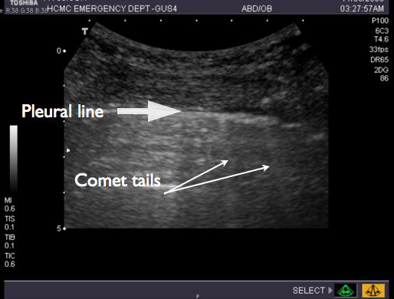
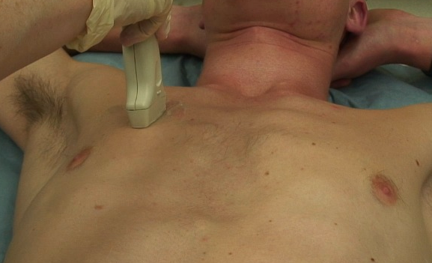
Figure 19: Chest wall probe positioning for evaluation of pneumothoraces
Figure 20: Sliding pleural line with comet tails

The minimal amount of intraperitoneal fluid that can be detected by an E-FAST exam depends on positioning of the patient, location of injury, and the location of the fluid¹. A good quality FAST can probably reliably detect about 200mL of free intraperitoneal fluid². There is evidence that even smaller amounts of fluid can be detected in the pelvic view, however this is a more technically difficult view^{3,4}. Overall, the FAST exam is about 90% sensitive for detecting any amount of intraperitoneal free fluid⁶. Multiple studies have shown that bedside ultrasound is equivalent to, or more sensitive, than chest radiography for detecting pneumothoraces and hemothoraces¹⁰⁻¹⁷. Ultrasound can identify as little as 20mL in the pleural space⁸. In comparison, about 200mL of pleural fluid is required before it can be detected with on a chest x-ray⁷. Ultrasound has also been shown to be much quicker, taking about 1 minute versus 15 minutes for chest radiography⁹.

The E-FAST exam is rapid, portable, noninvasive and easily repeatable examination. In comparison to computed tomography (CT), advantages of ultrasound include the quick timing of the study, lack of exposure to significant levels of radiation or potentially nephrotoxic contrast materials. Disadvantages include the inability to determine the site of intraperitoneal bleeding, limited ability to evaluate the retroperitoneum, and inability to obtain adequate views due to body habitus, subcutaneous air, or excessive bowel gas²⁰.

References

1. Tayel VS and Kendall JT. Trauma in Practical Guide to Emergency Ultrasound. Cosby KS and Kendall JL, Editors. 2006, Lippencott Williams & Wilkins: Philadelphia, PA. pp. 43-86.
2. Tiling, T., B. Bouillon, and A. Schmid, Ultrasound in Blunt Abdomino-thoracic Trauma., in Blunt Multiple Trauma: Comprehensive Pathophysiology and Care., J. Border, M. Allgoewer, and S. Hansen, Editors. 1990, Marcel Dekker: New York, NY. p. 415-433.
3. Ma, O.J., et al., Evaluation of hemoperitoneum using a single- vs multiple-view ultrasonographic examination. Acad Emerg Med, 1995. 2(7): p. 581-6.
4. Jehle, D., G. Stiller, and D. Wagner, Sensitivity in detecting free intraperitoneal fluid with the pelvic views of the FAST exam. Am J Emerg Med, 2003. 21(6): p. 476-8.
5. Abrams, B.J., et al., Ultrasound for the detection of intraperitoneal fluid: the role of Trendelenburg positioning. Am J Emerg Med, 1999. 17(2): p. 117-20.
6. Ma, O.J., et al., Prospective analysis of a rapid trauma ultrasound examination performed by emergency physicians. J Trauma, 1995. 38(6): p. 879-85.
7. Juhl, J., Diseases of the pleura, mediastinum, and diaphragm., in Essentials of Radiologic Imaging., J. Juhl and A. Crummy, Editors. 1993, JB Lippincott: Philadelphia, PA. p. 1026.
8. Rothlin, M.A., et al., Ultrasound in blunt abdominal and thoracic trauma. J Trauma, 1993. 34(4): p. 488-95.
9. Sisley, A.C., et al., Rapid detection of traumatic effusion using surgeon-performed ultrasonography. J Trauma, 1998. 44(2): p. 291-6; discussion 296-7.
10. Kirkpatrick, A.W., et al., Hand-held thoracic sonography for detecting post-traumatic pneumothoraces: the Extended Focused Assessment with Sonography for Trauma (EFAST). J Trauma, 2004. 57(2): p. 288-95.
11. Ball, C.G., et al., Factors related to the failure of radiographic recognition of occult posttraumatic pneumothoraces. Am J Surg, 2005. 189(5): p. 541-6; discussion 546.
12. Lichtenstein, D.A. and Y. Menu, A bedside ultrasound sign ruling out pneumothorax in the critically ill. Lung sliding. Chest, 1995. 108(5): p. 1345-8.
13. Lichtenstein, D., et al., The comet-tail artifact: an ultrasound sign ruling out pneumothorax. Intensive Care Med, 1999. 25(4): p. 383-8.
14. Lichtenstein, D. and G. Meziere, Ultrasound probably has a bright future in the diagnosis of pneumothorax. J Trauma, 2002. 52(3): p. 607.
15. Lichtenstein, D., et al., Comparative diagnostic performances of auscultation, chest radiography, and lung ultrasonography in acute respiratory distress syndrome. Anesthesiology, 2004. 100(1): p. 9-15.
16. Lichtenstein, D.A., et al., Ultrasound diagnosis of occult pneumothorax. Crit Care Med, 2005. 33(6): p. 1231-8.
17. Lichtenstein, D., et al., The "lung point": an ultrasound sign specific to pneumothorax. Intensive Care Med, 2000. 26(10): p. 1434-40.
18. Ma. OJ and Mateer J. Trauma ultrasound examination versus chest radiography I the detection of hemothorax. Ann Emerg Med, 1997. 29 (3): p. 312-5; discussion 315-6.
19. Dulchavsky SA, et all. Proscpective evaluation of thoracic ultrasound in the detection of pneumothorax. J Trauma, 2001. 50(2): p. 201-5.
20. Ma OJ, Mateer JR, and Blaivas M. Emergency Ultrasound, Second Edition. Sydor A and Boyle P editors. 2008 by The McGraw-Hill Companies, Inc: p78

